
Form 3
Design
Title : Integrated Operational Management System for C3MR: Web Admin Portal & Telegram Mini App Ecosystem

GROUP MEMBER:
No. | Student Name | Student ID | Study Program
1. | Auza Syamil Nabawi | 001202300150 | Informatics
2. | Rashad Abdul Faqih | 001202300149 | Informatics
3. | Atthariqul Hazam Albanna | 012202300122 | Information System

Advisor : Dr. Adhi Setyo Santoso, ST.MBA.

Submitted for
Capstone Design Project
Faculty of Computer Science
President University
2026

TABLE OF CONTENT
STATEMENT OF ORIGINALITY 3
PART 3 : DESIGN 4
A. SYSTEM DESIGN 4
Overview 4
System Architecture 5
Mock-up Designs 6
B. HIERARCHICAL / ITERATIVE DESIGN 11
1. Data Flow Diagram 11
2. Interface Information Between Components 12
3. Software Engineering Design Steps 12
4. Component References and Libraries 13
5. UML Diagrams 14
C. STANDARDS USED 17
D. IMPLEMENTATION AND TESTING SCENARIO 18
A. Implementation Overview 18
B. Testing Scenarios 19
REFERENCES 22

STATEMENT OF ORIGINALITY
In my capacity as an active student at President University and as the author of the Capstone Design Project stated below:
Name : 1. Auza Syamil Nabawi – 001202300150
2. Rashad Abdul Faqih – 001202300149
3. Atthariqul Hazam Albanna – 012202300122
Faculty : Computer Science
I hereby declare that my Capstone Design Project entitled “Integrated Operational Management System for C3MR: Web Admin Portal & Telegram Mini App Ecosystem” is to the best of my knowledge and belief, an original piece of work based on sound academic principles. If there is any plagiarism detected in this final project, I am willing to be personally responsible for the consequences of these acts of plagiarism and will accept the sanctions against these acts in accordance with the rules and policies of President University.
I also declare that this work, either in whole or in part, has not been submitted to another university to obtain a degree.

Cikarang, 2026
Signer 1 | Signer 2 | Signer 3
 | 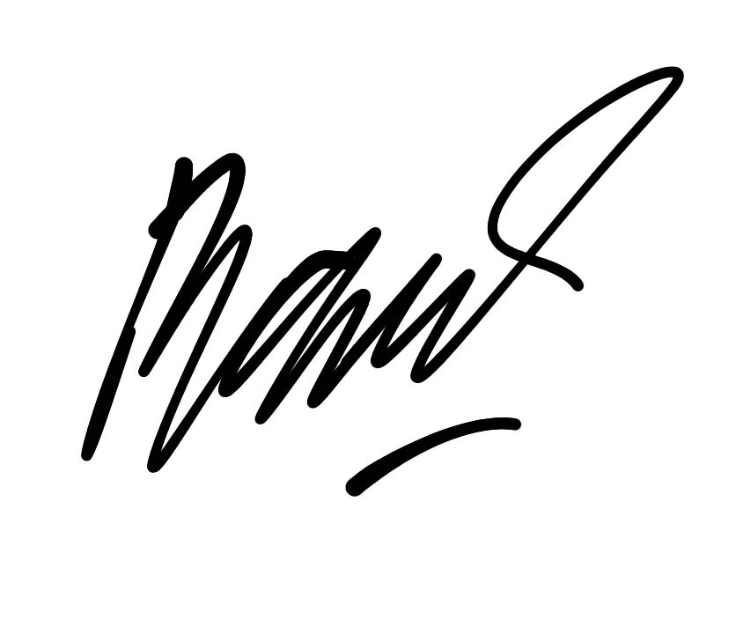 | 
Auza Syamil Nabawi  001202300150 | Rashad Abdul Faqih  001202300149 | Atthariqul Hazam Albanna  012202300122

PART 3 : DESIGN

Consists of:
A. SYSTEM DESIGN
B. HIERARCHICAL / ITERATIVE DESIGN
C. STANDARDS USED
D. FUNCTIONAL TESTING

A. SYSTEM DESIGN

Overview
C3MR (Collection Case & Customer Management Report) is designed to help managers and field officers handle collection activities in a more organized and trackable way. Instead of relying on manual coordination, the system brings target assignment, visit reporting, progress monitoring, and evidence upload into one connected workflow. To support that workflow, the system is organized into three main layers: Presentation Layer, Business Logic Layer, and Data Storage Layer.
System Architecture
The overall architecture of C3MR is shown in the diagram below:
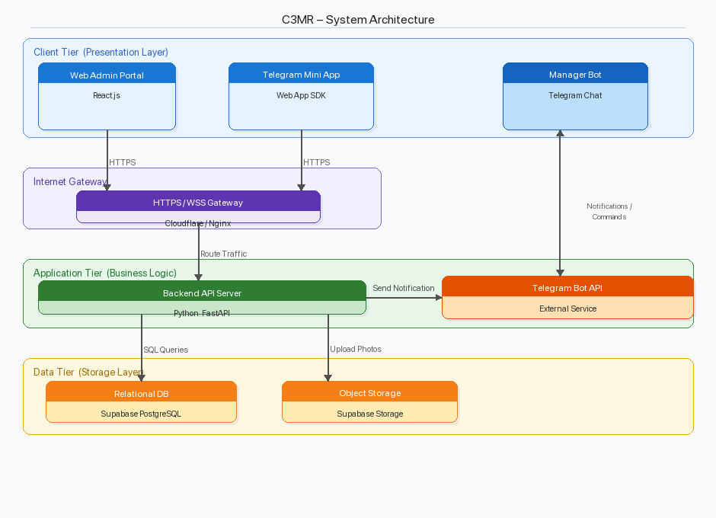

Figure A.1 C3MR System Architecture Diagram
To make the role of each component easier to understand, the architecture is divided into the following tiers:
1. Client Tier (Presentation Layer)
- Web Admin Portal (React.js): A browser-based dashboard used by managers to upload collection targets (CSV), assign officers, and monitor progress in real time.
- Telegram Mini App (Web App SDK): A lightweight mobile interface embedded within Telegram, used by field officers to view assigned tasks, fill visit reports, upload photo evidence, and submit results.
- Manager Bot (Telegram Chat): A Telegram bot that allows managers to receive notifications and issue commands (e.g., reassign targets, view summaries).
2. Internet Gateway
- HTTPS / WSS Gateway (Cloudflare / Nginx): Acts as a reverse proxy and load balancer handling SSL termination, rate limiting, and request routing.
3. Application Tier (Business Logic)
- Backend API Server (Python FastAPI): Handles all API requests, validates input data via Pydantic, executes business logic (task assignment, report processing, status updates), and communicates with the database.
4. Data Tier (Storage Layer)
- Relational Database (Supabase PostgreSQL): Stores user accounts, collection targets, visit reports, officer assignments, and audit logs.
- Object Storage (Supabase Storage): Stores photo evidence from field visits.

Mock-up Designs

Web Admin Portal – Login Page
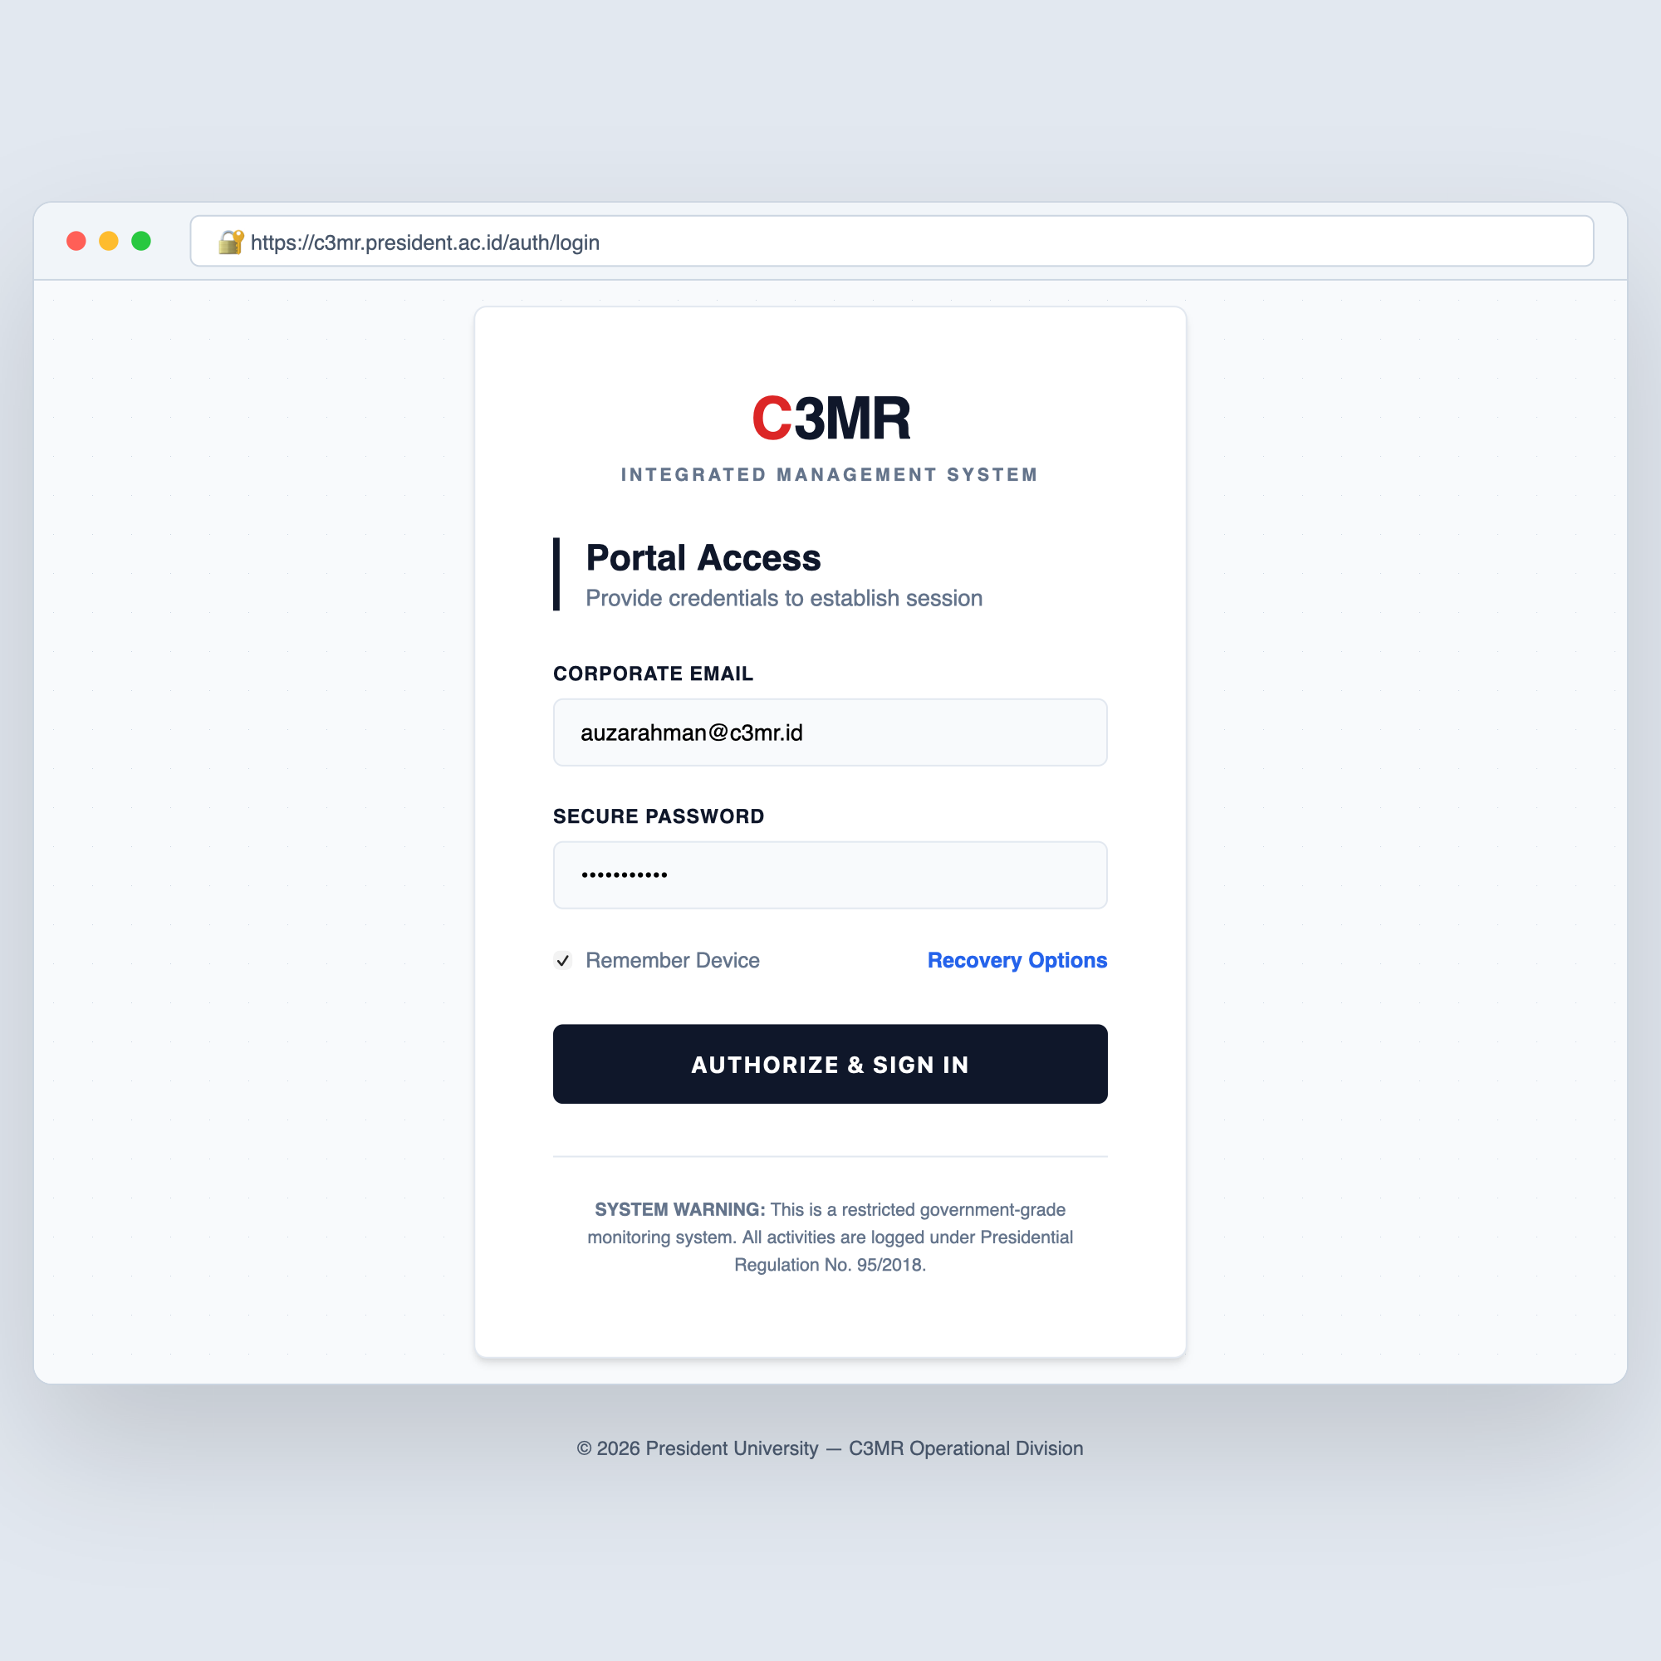

Figure A.2a Web Admin Portal – Login Page
The Login Page is used by authorized managers to access the C3MR Web Admin Portal. This page focuses on account verification and secure access, with the following main interface elements:
- Email and Password input fields with validation.
- Login button that authenticates via Supabase Auth and stores a JWT token.
- Forgot Password link for credential recovery.
- Access restriction notice — only whitelisted manager accounts can log in.

Web Admin Portal – Target Management Dashboard
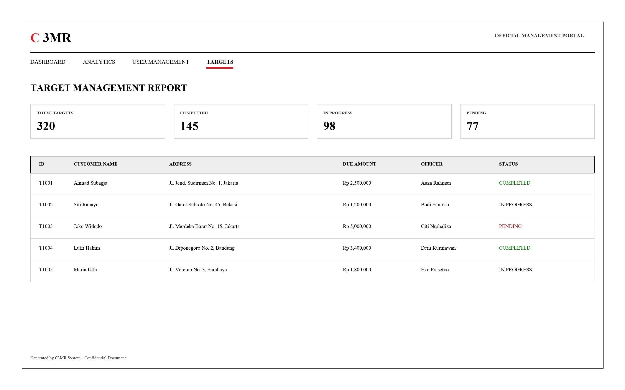

Figure A.2b Web Admin Portal – Target Management Dashboard
The Target Management Dashboard is the main working page for managers after login. Through this page, managers can monitor collection progress and manage target data using the following interface elements:
- Navigation Tabs: Dashboard, Analytics, User Management, Targets.
- System Summary: Four stat cards — Total Targets (320), Completed (145, green), In Progress (98, yellow), and Pending (77, red).
- Target List Table: Sortable/filterable table showing Target ID, Customer Name, Address, Amount Due, assigned Officer, and Status (Completed / In Progress / Pending) with color-coded status labels.

Telegram Mini App Mock-up
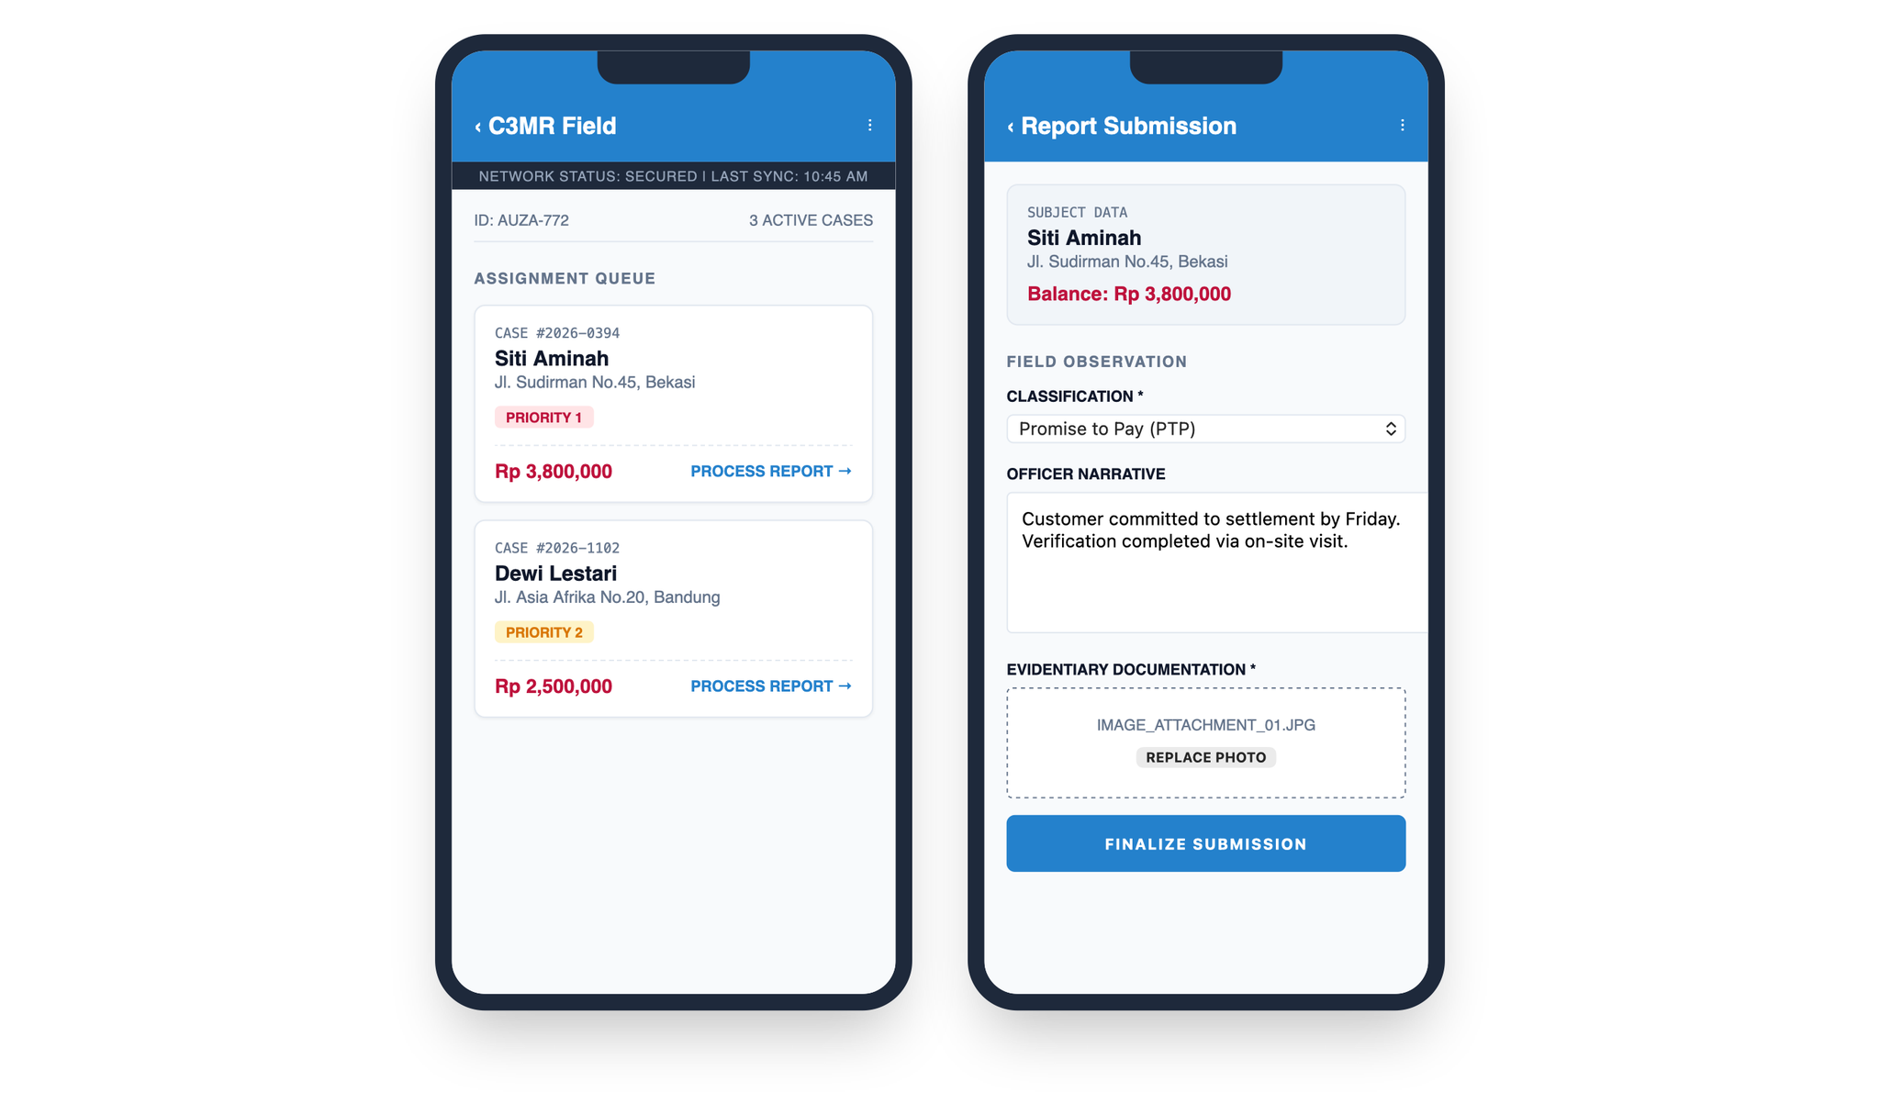

Figure A.3 Telegram Mini App Mock-up
The Telegram Mini App is designed for field officers who need a simple and practical mobile interface while working in the field. The main interface elements shown in this mock-up are:
- Header: App name "C3MR Field App" with back navigation.
- Task Detail: Displays the current task with customer name, address, phone number, and amount due (highlighted in red).
- Payment Status Dropdown: Selectable options — Promise to Pay, Paid, Refused, Not Home, Partial Payment.
- Notes Field: Scrollable text area for the officer to enter visit notes.
- Upload Photo Evidence Button: Triggers the device camera or gallery.
- Submit Report Button: Sends the completed report to the backend API.

Manager Bot Mock-up
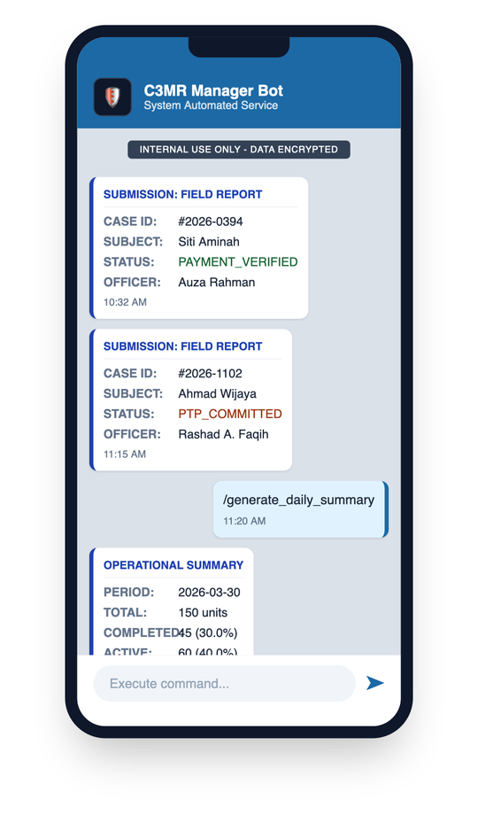

Figure A.4 Manager Bot Mock-up
The Manager Bot is intended to give managers quick updates and simple command-based access through Telegram. The main interaction elements shown in this mock-up are:
- Automatic Notifications: Each time a field officer submits a report, the bot sends a message to the manager's Telegram chat containing the customer name, payment status, officer name, and submission time.
- summary Command: The manager sends /summary and the bot replies with a real-time summary showing total targets, completed, in-progress, and pending counts.

B. HIERARCHICAL / ITERATIVE DESIGN

1. Data Flow Diagram
Level 0 – Context Diagram
The Level 0 (Context) Diagram summarizes the highest-level data flow between the three external entities and the C3MR system:
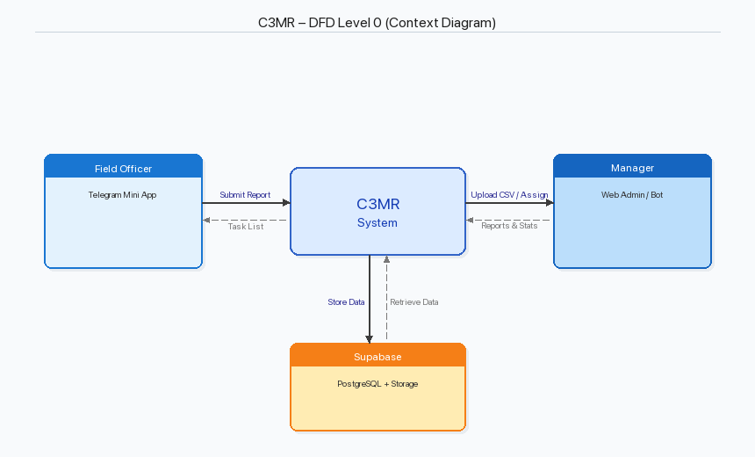

Figure B.0 DFD Level 0 – Context Diagram
- Level 1 – Major Processes
1.0 Authentication & Authorization: Handles user login (Supabase Auth for admin, Telegram user validation for officers), session management, and role-based access control.
2.0 Target Management: Manages CSV upload, parsing, validation, and assignment of collection targets to field officers.
3.0 Report Management: Processes field visit reports including form data validation, photo upload to object storage, and database insertion.
4.0 Officer Management: CRUD operations for field officer records, including linking Telegram user IDs.
5.0 Dashboard & Analytics: Aggregates data for the admin dashboard: total targets, completion rates, officer performance.
6.0 Notification Service: Sends task assignment notifications and status updates via the Telegram Bot API.

- Level 2 – Report Submission & Notification Process (Detailed)
The Level 2 diagram focuses on the report submission flow and the notification process sent to the manager. In this document, that flow is represented in Figure B.3 – Sequence Diagram, which shows how the Field Officer, Telegram Mini App, FastAPI backend, Supabase database, Telegram Bot API, and Manager interact step by step.

2. Interface Information Between Components
- Client ↔ Gateway: Protocol: HTTPS (TLS 1.3); Data format: JSON; Authentication: Bearer token.
- Gateway ↔ Backend API: Protocol: HTTP (internal); Headers forwarded: Authorization, X-Forwarded-For.
- Backend API ↔ Database: Protocol: PostgreSQL wire (TCP); Interface: superbase-py SDK; Parameterized SQL queries.
- Backend API ↔ Object Storage: Protocol: HTTPS; Interface: Supabase Storage API; Multipart file upload; Returns public URL.
- Backend API ↔ Telegram Bot API: Protocol: HTTPS; HTTP POST with JSON; sendMessage / sendPhoto endpoints.

3. Software Engineering Design Steps
The project uses an Agile or iterative approach so development can be carried out gradually and adjusted based on feedback from each stage:
- Requirements Gathering: The team identifies stakeholder needs, translates them into user stories, and prioritizes them in a product backlog.
- System Design: The team prepares the architecture diagrams, API contracts (OpenAPI specification), database schema, and UI mock-ups before implementation starts.
- Sprint-based Implementation: Features are developed incrementally in 2-week sprints, starting from authentication, target upload, and report submission.
- Testing: Validation is carried out through unit testing (pytest), API integration testing, and User Acceptance Testing (UAT) with stakeholders.
- Deployment: After the main features are stable, the backend is deployed to the server, the Supabase project is configured, the Telegram bot is registered, and the Mini App is published.
- Review & Iteration: Feedback from testing and users is used as the basis for fixing issues and improving the next iteration.

4. Component References and Libraries
- Frontend – Web Admin Portal
- React.js (v18.x) – UI framework
- React Router (v6.x) – Client-side routing
- Axios – HTTP client for API calls
- Tailwind CSS – Utility-first CSS framework
- Papa Parse – CSV parsing library
- Chart.js / Recharts – Dashboard chart rendering
- Frontend – Telegram Mini App
- Telegram Web App SDK – Native Telegram integration
- HTML5 / CSS3 / JavaScript – Core web technologies
- Fetch API – HTTP client for API calls
- Backend
- Python (v3.11+) – Programming language
- FastAPI (v0.100+) – Web framework
- Pydantic (v2.x) – Data validation and serialization
- supabase-py – Supabase Python client SDK
- python-telegram-bot – Telegram Bot API wrapper
- Uvicorn – ASGI server
- python-multipart – File upload handling
- Database & Storage
- Supabase – Backend-as-a-Service platform
- PostgreSQL (v15) – Relational database
- Supabase Storage – S3-compatible object storage
- Supabase Auth – Authentication service

5. UML Diagrams
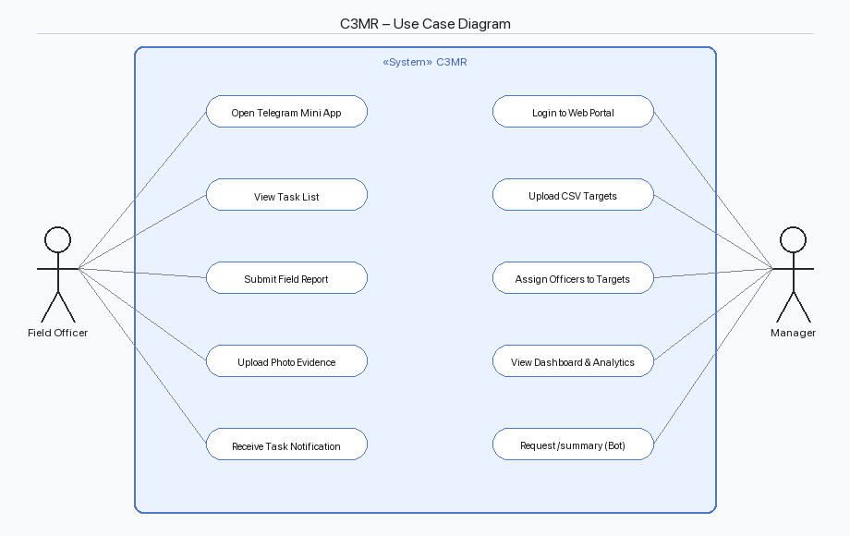

Figure B.1 Use Case Diagram
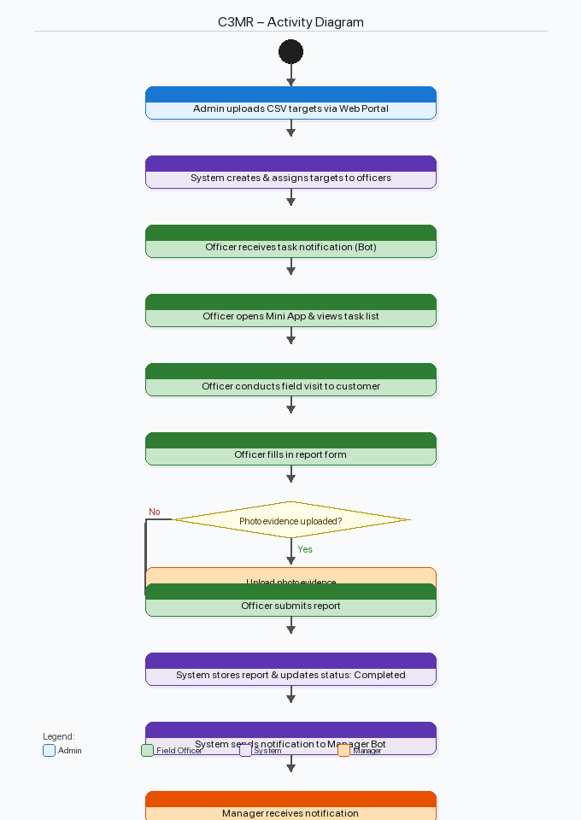

Figure B.2 Activity Diagram – C3MR Main Workflow
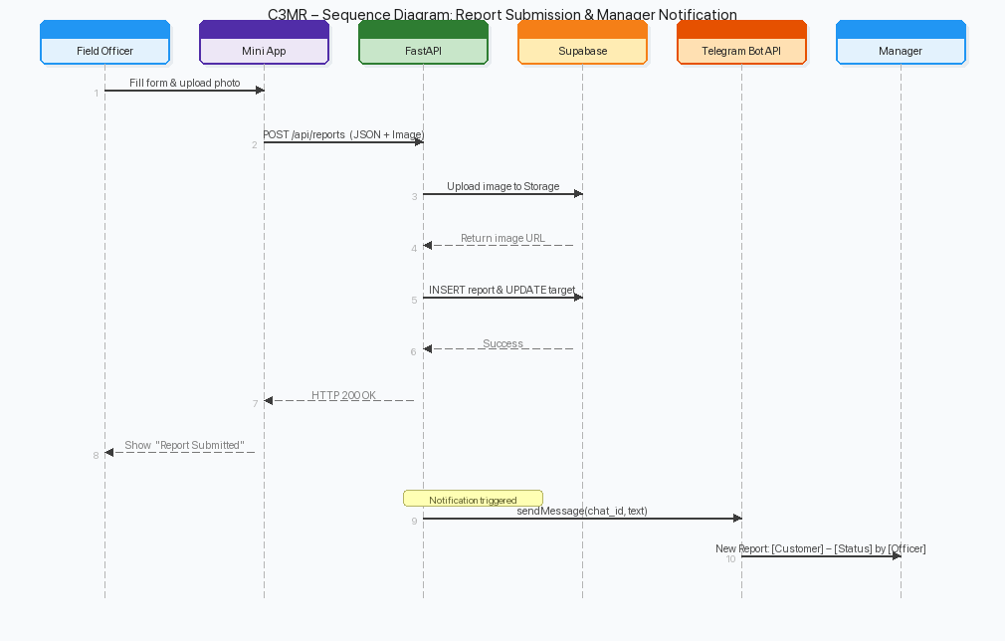

Figure B.3 Sequence Diagram – Report Submission & Manager Notification
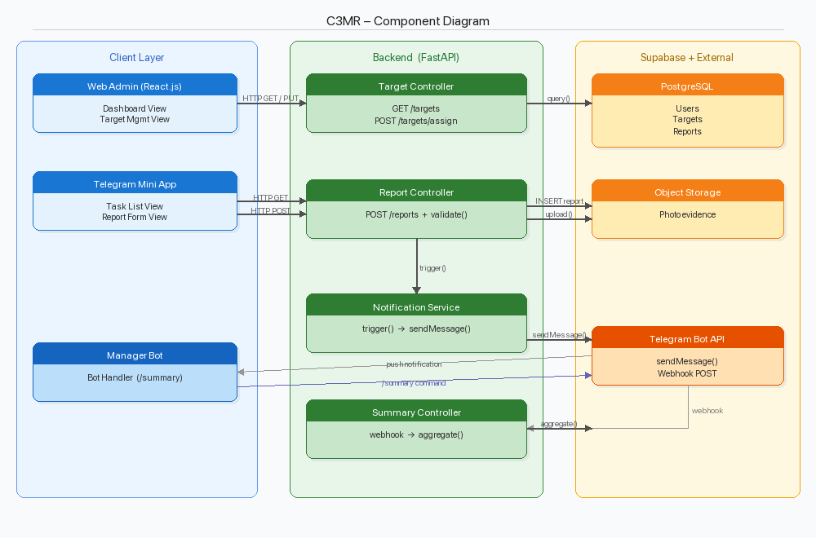

Figure B.4 Component Diagram
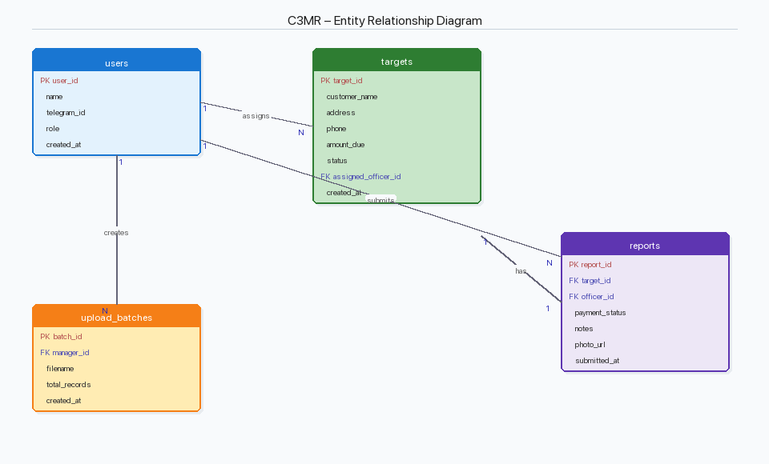

Figure B.5 Entity Relationship Diagram

C. STANDARDS USED
Category | Standard / Technology | Description
Data Format | JSON (RFC 8259) | All API request/response bodies use JSON.
API Architecture | REST (RESTful API) | Resource-based URLs, HTTP methods, status codes.
API Documentation | OpenAPI 3.0 | FastAPI auto-generates OpenAPI 3.0 spec (Swagger UI).
Data Validation | Pydantic v2 | Strict type checking and custom validators on all inputs.
Authentication | JWT (RFC 7519) | Supabase Auth issues JWTs upon login.
Encryption | TLS 1.3 (RFC 8446) | All client-server communication encrypted via HTTPS.
Database | SQL (PostgreSQL 15) | Standard SQL with PostgreSQL extensions.
Modeling | UML 2.5 | Use case, class, sequence, activity, component, ERD.
Diagram Tool | Python Pillow (v10.x) | All UML & architecture diagrams rendered programmatically as PNG.
Code Formatter | Black (Python) | Line length 88 (default settings).
Code Formatter | Prettier (JS/TS) | Frontend JavaScript/TypeScript formatting.
Linter | Ruff (Python) | Fast, comprehensive style and error checking.
Linter | ESLint (JS/TS) | Frontend code linting with recommended rules.
CSS Framework | Tailwind CSS v3 | Utility-first CSS for consistent, responsive styling.
Version Control | Git | GitHub as the remote repository host.
File Upload | Multipart/form-data (RFC 7578) | Photo evidence uploads.
CSV Format | RFC 4180 | Target data CSV files.
Bot API | Telegram Bot API v7 | Official Bot API for messages and Mini App integration.
Character Encoding | UTF-8 | All text data throughout the system.
Date/Time Format | ISO 8601 | All timestamps (e.g., 2024-01-15T10:30:00Z).

D. IMPLEMENTATION AND TESTING SCENARIO

Implementation Overview
The implementation of C3MR is planned in four iterative phases so each major component can be built, tested, and refined in a manageable sequence:
- Phase 1 – Backend Foundation
- Set up FastAPI project with Uvicorn as the ASGI server.
- Configure Supabase project (PostgreSQL database, Storage buckets, Auth).
- Define database schema and create tables (users, targets, reports, upload_batches).
- Implement authentication middleware using Supabase JWT verification.
- Implement core API endpoints: user registration, target CRUD, report submission.
- Phase 2 – Web Admin Portal
- Set up React.js project with Tailwind CSS.
- Implement login page with Supabase Auth integration.
- Build dashboard page with summary statistics and charts.
- Build target management page with CSV upload and officer assignment.
- Build report viewing page with filtering and search.
- Phase 3 – Telegram Mini App & Bot
- Register Telegram bot via BotFather and configure webhook.
- Implement Mini App using Telegram Web App SDK.
- Build task list view and report submission form.
- Implement photo capture and upload functionality.
- Implement Manager Bot commands for notifications and quick actions.
- Phase 4 – Integration & Testing
- End-to-end integration testing across all components.
- User Acceptance Testing (UAT) with stakeholders.
- Performance testing and optimization.
- Bug fixes and final adjustments.

Testing Scenarios
Scenario 1: Manager Login (Web Admin Portal)
Step | Action | Expected Result | Alternative
1 | Manager navigates to the Web Admin Portal URL. | Login page is displayed with email and password fields. | If server is unreachable, show 'Unable to connect' error.
2 | Manager enters valid email and password, clicks 'Login'. | System authenticates via Supabase Auth, redirects to Dashboard. JWT stored in local storage. | If credentials invalid, show 'Invalid email or password'. User stays on login page.
3 | Manager enters email but leaves password empty. | Client-side validation shows 'Password is required'. No API call is made. | –
4 | Manager's JWT token expires during session. | System detects 401 response, redirects to login with 'Session expired' message. | –

Scenario 2: Upload CSV Targets (Web Admin Portal)
Step | Action | Expected Result | Alternative
1 | Manager clicks 'Choose CSV' button. | File picker opens, filtered to .csv files. | –
2 | Manager selects valid CSV with correct columns. | File name displayed. Preview of first 5 rows shown. | If CSV has wrong columns, show format error.
3 | Manager clicks 'Upload & Assign'. | System parses CSV, creates target records. Success: '150 targets uploaded.' | If any row has invalid data, show row-level error. Upload rejected.
4 | Manager uploads CSV with 0 data rows. | Show 'CSV file contains no data rows' error. | –
5 | Manager uploads a non-CSV file (e.g., .xlsx). | Client-side validation: 'Only .csv files are accepted.' | –

Scenario 3: Assign Targets to Officers (Web Admin Portal)
Step | Action | Expected Result | Alternative
1 | Manager selects unassigned targets. | Selected targets highlighted. 'Assign' button becomes active. | –
2 | Manager clicks 'Assign' and selects officer. | Targets assigned. Status → 'In Progress'. Telegram notification sent to officer. | If officer is at max capacity, show warning.
3 | Manager attempts to reassign an already-assigned target. | Confirmation dialog appears. On confirm, reassignment proceeds. | If manager cancels, no changes made.

Scenario 4: Field Officer Views Task List (Telegram Mini App)
Step | Action | Expected Result | Alternative
1 | Field Officer opens the Mini App from Telegram. | System validates Telegram user ID. Task list displayed. | If ID not registered, show 'Contact your manager' message.
2 | Task list loads with assigned targets. | Each task shows customer name, address snippet, amount due, and status badge. Sorted by status (Pending first). | If no tasks, show 'No tasks assigned. Check back later.'
3 | Officer taps on a task. | Task detail view opens with full customer info (name, address, phone, amount due). | –

Scenario 5: Field Officer Submits Report (Telegram Mini App)
Step | Action | Expected Result | Alternative
1 | Officer opens task detail and taps 'Submit Report'. | Report form displayed with Payment Status dropdown, Notes, and Upload button. | –
2 | Officer selects payment status (Promise to Pay / Paid / Refused / Not Home / Partial Payment). | Selection recorded. Dropdown shows selected value. | –
3 | Officer types notes. | Text recorded in notes field. | –
4 | Officer taps 'Upload Photo Evidence'. | Camera or gallery opens. | If permission denied, show 'Please grant camera access.'
5 | Officer captures/selects a photo. | Photo thumbnail preview displayed. | If photo > 10 MB, show size limit error.
6 | Officer taps 'Submit Report' with all fields filled. | POST /api/reports sent. Photo uploaded. Report inserted. Target → 'Completed'. Success message shown. Officer returned to task list. | If network error, show retry message. Form data preserved.
7 | Officer taps 'Submit Report' without payment status. | Validation error: 'Please select a payment status.' Form not submitted. | –
8 | Officer taps 'Submit Report' without photo. | Validation error: 'Please upload photo evidence.' Form not submitted. | –
Scenario 6: Manager Views Dashboard (Web Admin Portal)
Step | Action | Expected Result | Alternative
1 | Manager navigates to Dashboard page. | Dashboard loads with 4 summary cards (Total Targets, Completed, In Progress, Pending) and completion rate chart. | If no data, show 'Upload targets to get started.'
2 | Manager views Target List table. | Table shows: ID, Customer, Address, Amount Due, Officer, Status, Actions. Supports sorting and filtering by status. | –
3 | Manager clicks on a completed target row. | Target detail view shows customer info and submitted report (payment status, notes, photo evidence). | –

Scenario 7: Manager Bot Notifications (Telegram)
Step | Action | Expected Result | Alternative
1 | A field officer submits a report. | Manager receives Telegram notification: '📋 New Report: [Customer] – [Payment Status] by [Officer].' | If bot blocked by manager, notification fails silently. Log error.
2 | Manager sends /summary to the bot. | Bot responds with total targets, completed, pending count, and completion %. | If no targets, bot replies 'No targets found.'

REFERENCES
Bray, T. (Ed.). (2017). The JavaScript Object Notation (JSON) data interchange format (RFC 8259). Internet Engineering Task Force (IETF). https://datatracker.ietf.org/doc/html/rfc8259
Jones, M., Bradley, J., & Sakimura, N. (2015). JSON web token (JWT) (RFC 7519). Internet Engineering Task Force (IETF). https://datatracker.ietf.org/doc/html/rfc7519
Meta Open Source. (n.d.). React documentation. Meta. https://react.dev/
Pillow Contributors. (n.d.). Pillow (PIL fork) documentation. https://pillow.readthedocs.io/
Pydantic. (n.d.). Pydantic documentation. https://docs.pydantic.dev/
Ramírez, S. (n.d.). FastAPI documentation. Tiangolo. https://fastapi.tiangolo.com/
Supabase. (n.d.). Supabase documentation. https://supabase.com/docs
Tailwind Labs. (n.d.). Tailwind CSS documentation. https://tailwindcss.com/docs
Telegram. (n.d.). Telegram bot API documentation. https://core.telegram.org/bots/api
Telegram. (n.d.). Telegram mini apps documentation. https://core.telegram.org/bots/webapps

